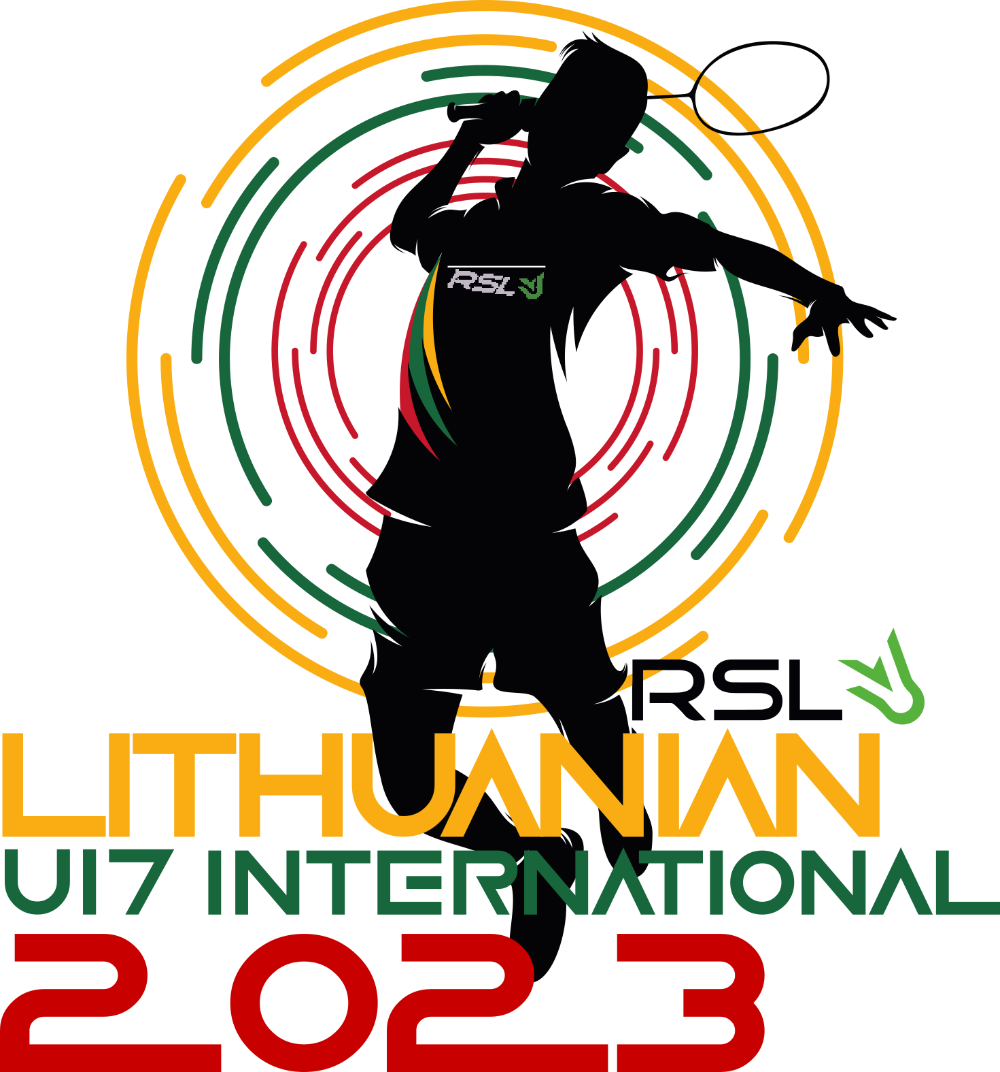

PART OF THE BADMINTON EUROPE U17 CIRCUIT

July 07 – 09, 2023
PRIENAI, LITHUANIA

OFFICIAL HOTEL BOOKING FORM
The booking form has to be sent by June 16th, 2023 (23:59) at latest
Send the filled booking form to rslu17int2023@badminton.lt

Contact information for the booking
Team
Contact name
E-mail address
Phone number
BOOKING LIST
Enter PLAYER, OFFICIAL OR FAMILY for Team Position.
Enter X for the accommodation you want to book for each member of your team.
No. | Given name | Family name | Gender  M / F | Team position | Arrival  dd/mm | Departure  dd/mm | Single | Double | Triple
1
2
3
4
5
6
7
8
9
10
11
12
13
14
15
Need more lines? Click in the last cell of the list and then press “Tab”.

AIRPORT TRANSFER
Kaunas Airport | Number of Passengers | Pick up Date | Pick up Hour | Flight Number

